**Assignment 1**

1. What happens when you login a non-existent users or username?

As the user does not exist it will through an error “user does not exist” as shown below



1. Login into your account and then change password.
2. Password didn’t change and got the “token manipulation error”

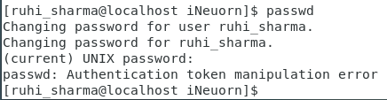

1. Failed to change the password and got the “token manipulation error”

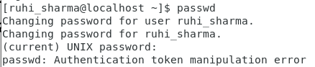

1. Got the “token manipulation error”

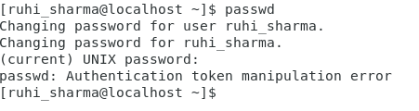

1. Working with Directories
2. From cd / we go into the root directory, and it lists all the files/directories/mount points under root directory along with the permissions files have

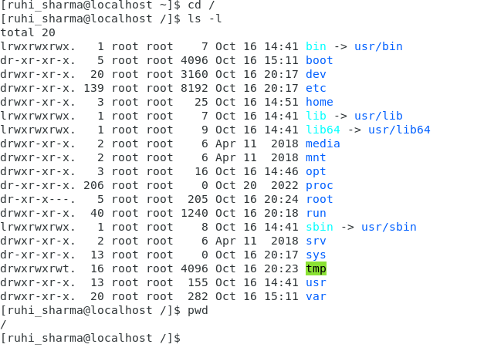

1. Home directory is basically a personal directory created when a new user is created for it’s personal use like in below e.g. Ruhi_sharma user is created and under /home it has created one home directory for ruhi_sharma user

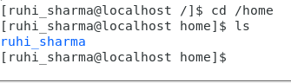

1. When we type cd .. it takes you one step back from the current path.

Like currently I was in /home/ruhi_sharma directory so when I type cd .. it took me to one directory back to /home

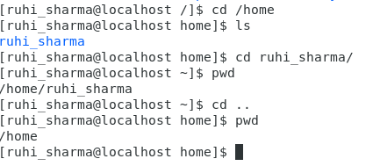

1. It through the error as www and html directory does not exist in /var mp . When we type cd only it will take us back to home directory

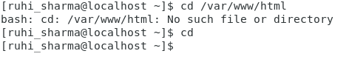

1. Got the permission denied error

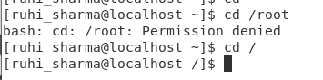

1. Working with File Listing
2. Under /etc directory it has system configuration files and ls simply list the name of files as shown

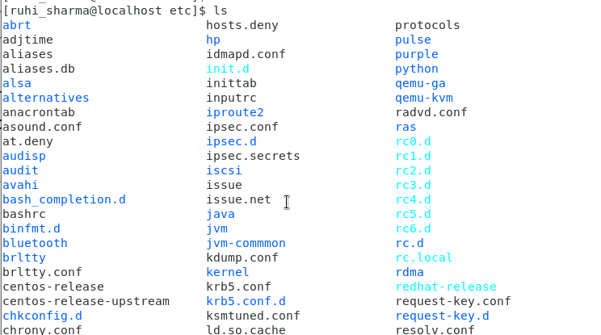

1. Ls -al list the files/directory with certain attributes like the owner, permission, creation date and time, last modified date or time , size,etc.

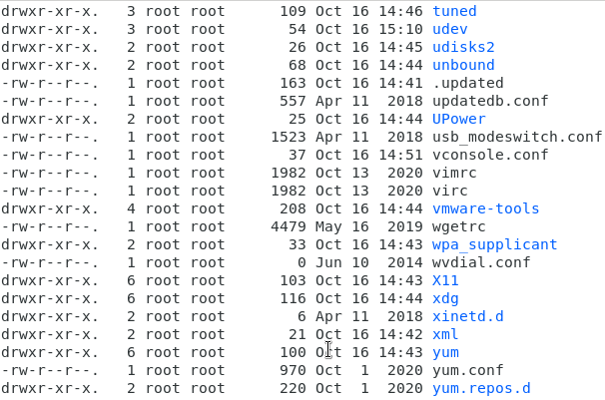

1. Ls -I list the file name along with the index number of file.

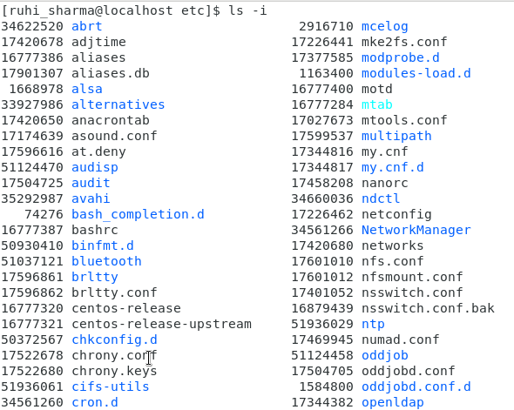

1. Ls –help, eg ls -X list the file in alphabetically order

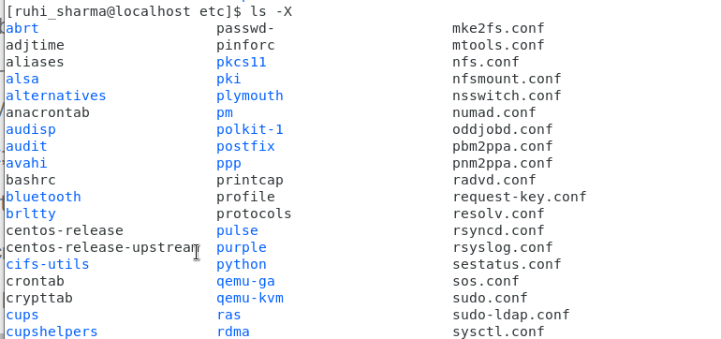

1. Know where you are and where you working
2. When we login into the system, we get into the /home directory of user with which we logged in as shown using pwd



1. Under /var directory it contain the files which are changed due to any operation or action happening on system like if we rebooted the server these logs will be written under /var/log

